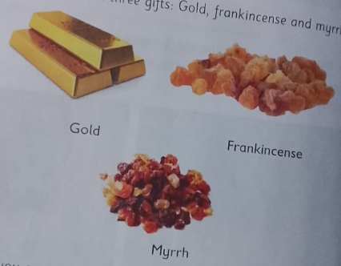
THREE GIFTS GIVEN TO BABY JESUS

